**ISD Message Creator**

**Getting Started - Define your Intersection**

1. Begin by navigating to the **File** drop down menu. Select **New Parent Map** or **New Child Map**.
   * Parent maps only allow reference points that define an intersection location whereas child maps define the features of a given parent map.
2. If you choose parent map, zoom into the intersection you wish you begin building.
3. From the top navbar, go to **Show** → **Builder** to bring up the menu to begin building your intersection.
   * In the **Intersection** tab, you should see the **Reference Point Marker** and the **Verified Point Marker**.

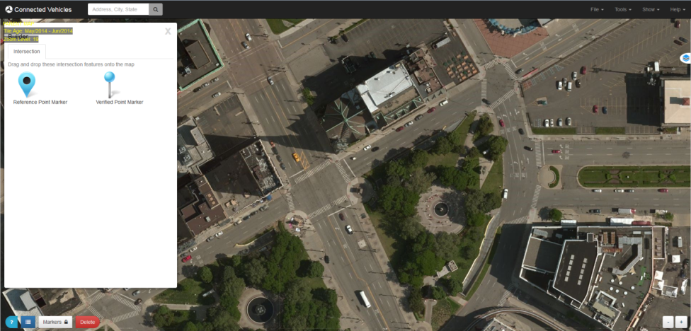

1. Click and drag the **Reference Point Marker** to the center of the intersection you wish to begin building.
   * Note that the **Markers** Control becomes enabled once the marker is placed.
   * You may drag around the marker after being placed to tweak its location
   * Click on the marker to open up the **Configuration** dialog. From here you can view and modify its information.
   * You may toggle the control back off once you are finished tweaking the location of the markers.

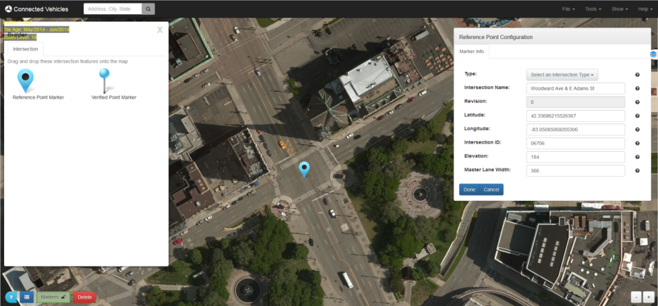

1. Click and drag the **Verified Point Marker** to a known, surveyed location on the map.
   * Click on the marker to open up the **Configuration** dialog. You can view the location of the marker on the map, as well as view and modify the verified location of the marker.
   * Check the verified marker information and edit as necessary. Click **Done** when finished.

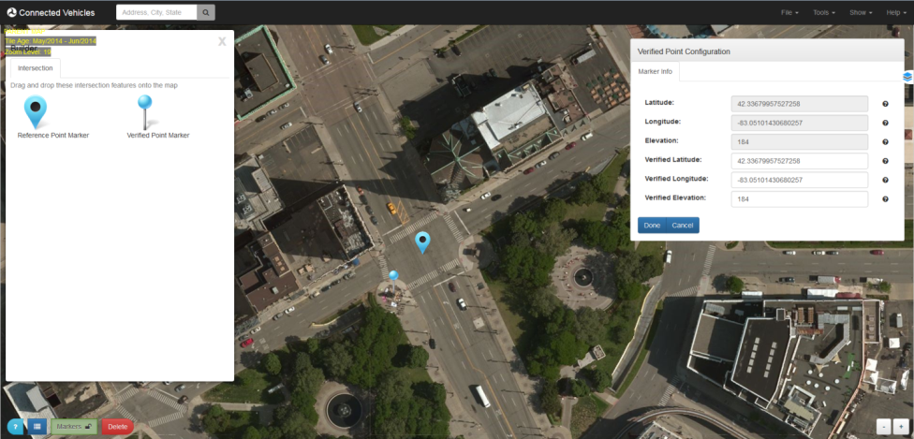

1. Close the **Builder** once you are finished placing the two markers.
2. Continue the process by following the **Save/Load** instructions.

**Saving/Loading an Intersection**

Use the save feature to save a parent or child map.

* Saving an Intersection
  1. From the top navbar, go to **File** → **Save**.
  2. Use your browser dialog to save the generated file to your local machine.
  3. You must save your parent map in order to build a child map.
* Loading an Intersection
  1. When building a child map, you must always load a parent map. You can also edit child maps using the load function.
  2. Begin by navigating to the **File** drop down menu. Select **New Child Map**.
  3. Another dialog window will appear on the screen which allows you to navigate your file system to find the appropriate parent map.
  4. Select and open the parent map.
  5. Use the **approaches**, **lanes**, and **attributes** instructions to build the child maps.

**Defining Approaches**

1. Click the **Draw Approaches** Control from the bottom Control Panel. The control should turn green when activated.
2. Drawing an Approach
   * Click and drag the mouse to create a rectangular box, symbolizing a stop bar, to define an approach. Make the box the approximate size of one of the stop bars in the intersection.
   * Do not worry about the exact size/shape/position of the box as it can be modified.

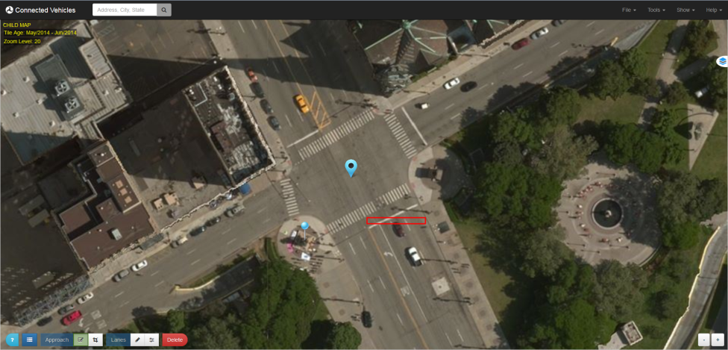

1. Modifying an Approach
   * Click the **Edit Approaches** Control on the bottom Control Panel.
   * Click the approach box you wish to modify.
   * Click and drag from the center dot on the approach to move the box around.
   * Click and drag from the outside dot to rotate and resize the box.
   * Modify the box as to best fit the stop bar of the intersection.

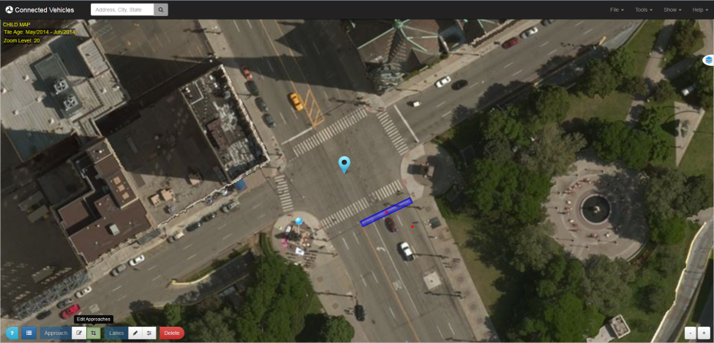

1. Configuring an Approach
   * Verify that all of the Controls on the bottom panel are unselected.
   * Click on the approach you wish to configure.
   * In the Approach Configuration dialog, configure as desired.
   * Click **Done** when finished.

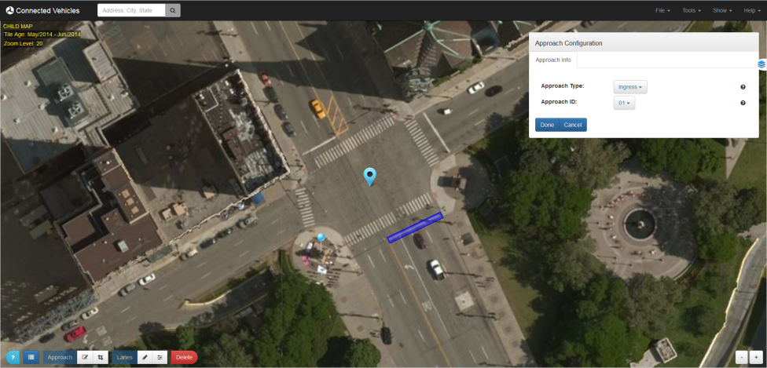

1. Repeat the above steps for each approach.
2. Removing an Approach
   * Select the **Delete** Control on the bottom panel.
   * Click the feature (approach) you wish to delete.
   * Unselect the **Delete** Control.

**Defining Lanes**

1. Click the **Draw Lanes** Control from the bottom Control Panel.
2. Drawing a Lane
   1. Place the mouse button inside of the approach box you wish to begin defining lanes.
   2. Click the mouse once to create the first node of the lane.
   3. Click the mouse again to define all subsequent nodes on the lane.
   4. Double-click the mouse on the final node you wish to define on the lane.

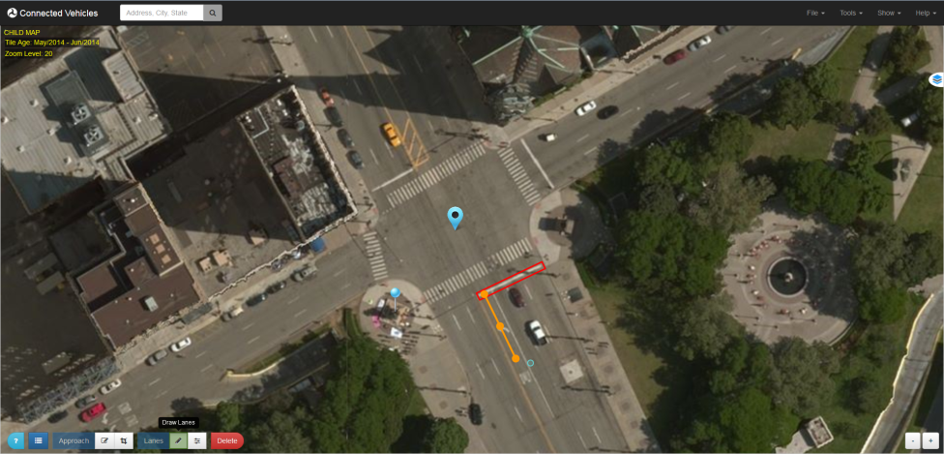

1. Modifying a Lane
   1. Click the **Edit Lanes** Control on the bottom Control Panel.
   2. Click the lane you wish to modify.
   3. All of the nodes on the lane will appear. The solid colored nodes are ones already defined. The transparent nodes are ones you can add to the lane by simply dragging them.
   4. Click and drag the nodes around until you have them in the desired position.

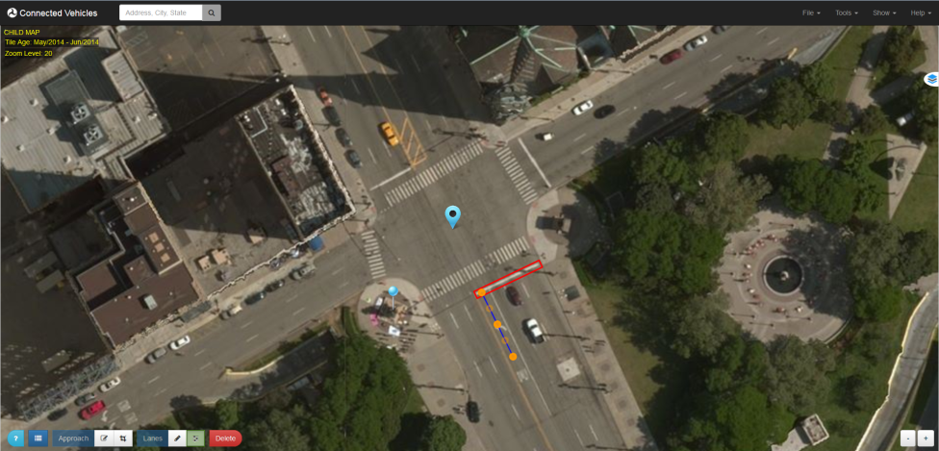

1. Configuring a Lane
   1. Verify that all of the Controls on the bottom panel are unselected.
   2. Click on the lane node you wish to configure in order to bring up the **Lane Configuration** dialog. Note: only the first node of the lane will hold the Lane Number and Attribute information.
   3. Define a Lane Number (node 1). Modify any other desired settings. Note: Lane Attributes will be explained in the next section.
   4. Click **Done** when finished.

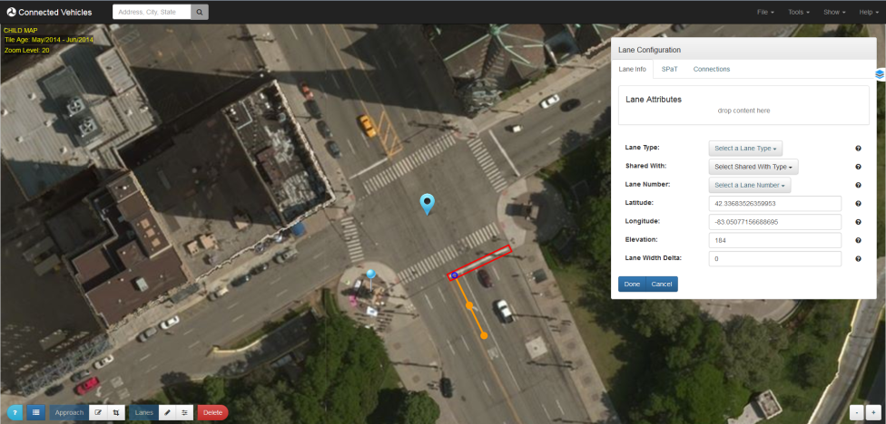

1. Repeat the above steps for each lane in each approach.
2. Removing a Lane
   1. Select the **Delete** Control on the bottom panel.
   2. Click the feature (lane) you wish to delete.
   3. Unselect the **Delete** Control.

**Lane Attributes**

* Adding Lane Attributes
  1. Click on the first node of the lane you wish you add attributes to; this will again display the **Lane Configuration** dialog.
  2. Bring up the **Builder** and select the **Lane** tab.
  3. Click and drag the lane attributes from the **Builder** to the **Lane Attributes** section of the **Lane Configuration**.
  4. Let go of the mouse button to "drop" and assign the attribute to the lane.
  5. Click **Done** when finished adding attributes.

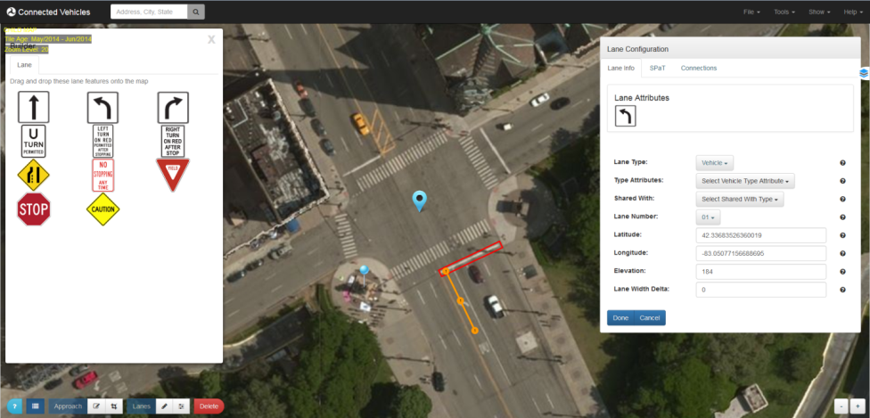

* Removing Lane Attributes
  1. Click on the first node of the lane you wish you remove attributes from.
  2. From the **Lane Attributes** section of the **Lane Configuration** dialog, click and begin to drag the attribute you wish to remove.
  3. Once the dragging begins, a red trashcan will appear at the bottom of the **Lane Attributes** section.
  4. Hover the attribute over the trashcan and let go of the mouse button to "drop" and remove the attribute from the lane.
  5. Click **Done** when finished removing attributes.

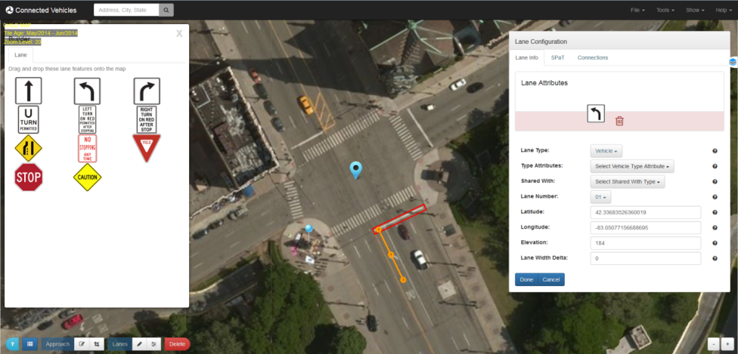

#### Finish and Encode

Encode your intersection message once you are finished building your intersection.

* From the top navbar, go to **Tools** → **Encoder**.
* Select desired Message Type
  + **ISD** – SDC/SDW Intersection Situation Data
  + **Map** – SAE J2735 MapData message
  + **Frame+Map** – SAE J2735 MessageFrame message with MapData contents
  + **SPaT** – SAE J2735 SPAT message
  + **Frame+SPaT** – SAE J2735 MessageFrame message with SPAT contents
  + **SpatRecord** – ISD message SPaT part
* Select desired nodes offsets encoding (in the descending order of the message size)
  + **Explicit (64 bit)** - SAE J2735 Node-LLmD-64b encoding using explicit lat/lon values
  + **Standard (32 bit)** - SAE J2735 Node-XY-32b offset values
  + **Compact** – determines and uses the same minimal SAE J2735 Node-XY-??b offset value encoding for all nodes
  + **Tight** - uses the absolute minimal SAE J2735 Node-XY-??b offset value encoding for each node
* Encode the Message
  + Press the **Encode** button to encode your message.
  + The **UPER Hex** text area box will display the UPER Hex encoded message if successful, or an error message if unsuccessful.

Note that content of all text areas can be selected and copied via context (right-click) menu option or using Ctrl-A (Select All) and Ctrl-C (copy) shortcuts.